

Poject

**Electronic braille Box User Manual**

(Osikoya’s Method)

A picture containing indoor, table

Description generated with very high confidence

Internet of Things Project Year 2

Bachelor of Software & Electronic Engineering

Galway-Mayo Institute of Technology

2017/2018

**Table of Contents**

Acknowledgements 3

1 Introduction 4

2 Parts of the Device and Connections 4

3 Setting up the Device 4

4 Using the Speech Synthesizer 5

5 Using the serial terminal 5

6 Solenoids and response 5

7 Troubleshooting 6

8 References 7

9 Notes 8

# Acknowledgements

Everything I wrote in this project is solely my work and serve to acts as a complimentary attribute to my internet of things project. Every time I have mentioned something I have used, I have referenced and cited it correctly; giving credit where it was respectfully due.

# Introduction

Braille is a form of written language for blind people, in which characters are represented by patterns of raised dots that are felt with the fingertips. [dictionary .com).

The braille box is designed to help visually impaired user enhance their knowledge of the alphabet and number system of the sequential language called braille and learn it with help of an assistant by the user’s side.

I implemented this by having six D frame solenoids to display refreshable braille sequences based on the user vocal request to the speech synthesizer

# Parts of the Device and Connections

When you are using the electronic Braille project it is important to connect the following parts:

* A 9V -12V external power supply, this will power the speech Synthesizer.
* An Arduino cable to power the separate Arduino board micro controller that has been configured to work with the solenoids.
* A 9v battery or external power supply which will power the solenoids for it to be possible to read the Braille equivalents and
* Lastly although optional if the assistant at that present time or individual wants to check or read the configured website dedicated to the braille box project they can do so by connecting the Arduino which hosts the Wi-Fi module to connect and view the website via their device.

# Setting up the Device

When setting up the place the solenoids near to the User so they can feel the Braille sequences as they say the letters or numbers

Place the microphone and speaker hosted on the speech Synthesizer near to user. Proximity to the microphone yields the best results also the speaker being kept near helps the user hear what is being speak clearly.

Takes picture’s and put in

Place the serial terminal which is hosted on the pc close to the assistant, so they can enter in the result received into the serial terminal and then the solenoids will pop up subsequently

# Using the Speech Synthesizer

When using the speech Synthesizer to say the letter or number you wish, you must make sure that the user is place within x metres of the microcontroller to be heard properly.

When voicing a vocal request to the microcontroller the user must make sure to say the callsign called Arduino. The callsign is how the microcontroller knows it's being called invoked and then knows to listen for a request to be made. Afterwards the callsign is said there will be a beep the user must wait for the beep to end. This is crucial as not wait will cause the microcontroller to interrupt your request as noise and therefore not comprehend your request. Once the beep has ended. The user can now say the letter or number they wish, and the speech Synthesizer will respond accordingly.

# Using the serial terminal

If you have reached this step it means you have successfully set up the device which is great! And if you are still having difficulty with step please refer to section: setting up the device.

The next step is accessing the serial terminal on the Arduino IDE because this is the part that makes it possible to see the solenoids in action demonstrating the Braille sequences. Open the folder Arduino sketch titled IOT_SOLENOIDS.

A close up of a sign

Description generated with high confidence

And now you access the serial terminal it by clicking the right hand top corner icon that looks like a magnifying glass which looks like this.

A screenshot of a cell phone

Description generated with very high confidence

once you have all of this set up this means you are nearly ready to begin.

When you are in serial terminal the assistant should simply type the letter that is heard from the Synthesizer and the solenoid Braille equivalent will pop up and it will also say it was received on the terminal which is show here:

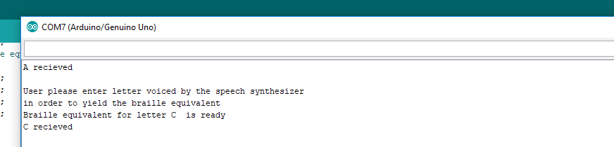

The process continues till the user says Arduino I'm done which will send the microcontroller to sleep until it's is invoke called again

# Solenoids and response

Testing solenoids

Solenoids will pop up for a duration of 5 seconds for the user to learn the sequence and the process will repeat until already mentioned

# Troubleshooting

* **Connecting the device and parts to connect**

If either the solenoids or microcontroller is not working the power is not connected properly and in the case of the solenoids the current being sent is not enough

Here is a schematic of how the device is to be connected:

A circuit board

Description generated with high confidence

* **Setting up the device**

If you aren't getting a beep, a proper response or a response at all the microphone is too far away or the environment you are in is too loud. This can be solved by increased the threshold in the speech synthesizer or moving to a less noisy environment.

If the serial terminal is not open check to see if it is opened already

And check that it on the port that is initialized to that individual Arduino as this is what serial communication possible

if the Arduino isn’t lighting then there might be several issues that you need to address

1. The Arduino isn’t connected to the pc via the USB cable available and this means that the Arduino is it not receiving the proper volts it needs.
2. The Pc may be turned off, so make sure to turn on your PC for activity to take place

* **Using Synthesizer prolonged wait period**

If you didn't get a response this means that you didn't say your request loud enough and then the mini beeper on the speech synthesizer wont sound. To fix this re upload the code or press the reset button on the microcontroller

Which is located here:

* **Typing to serial terminal and how to access it**

make sure you are typing into the tab and press the enter for serial communication between the terminal and the solenoids to be possible

* **Solenoids and Response**

Solenoids will pop up for a duration of 5 seconds for the user to learn the sequence and the process will repeat. However, if this does not occur then check if your solenoids are wired up correctly see figure [number it] and are receive the appropriate voltage

# Braille Alphabet

Here is an attached copy of the braille alphabet for the assistant to utilize to see which braille sequence is being presented on the braille cell when the user is using the device:

A screenshot of a cell phone

Description generated with high confidence

# Notes

End of User Manual